Admin UI and use case:

Add new user

Default screen:

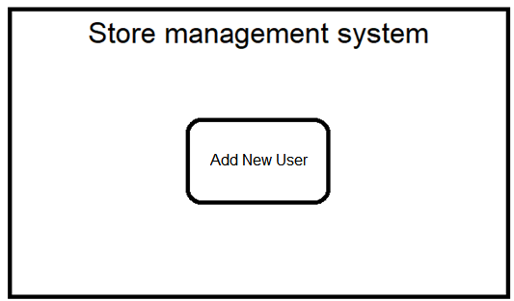

Add user screen after clicking “Add New User” on default screen and inputting all the info:

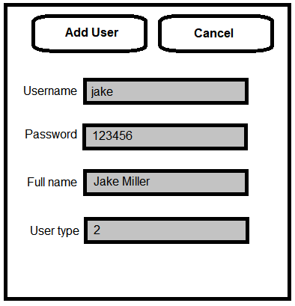

After clicking add user:

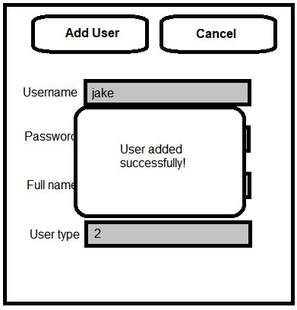

Manager UI and use case:

Add/update new product:

Default:

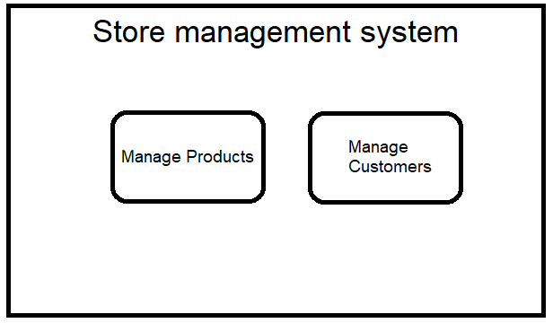

Product load screen after typing in product ID and clicking load:

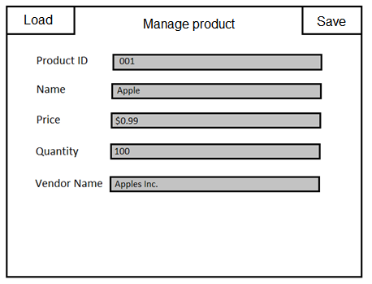

Product after changing info to desired and clicking save:

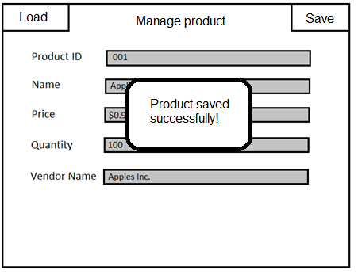

Cashier UI and Use case:

Add new customer or update a current customer:

Default:

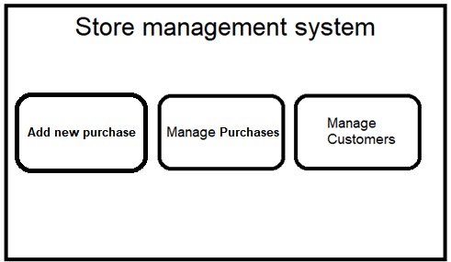

Clicking “Manage customers” and putting in the customer ID and click load:

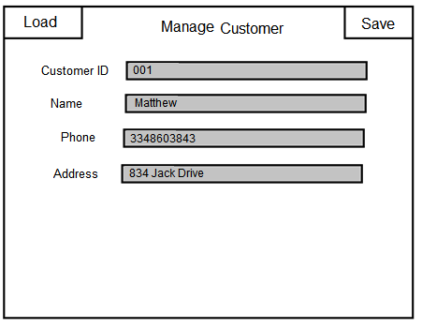

Clicking save:

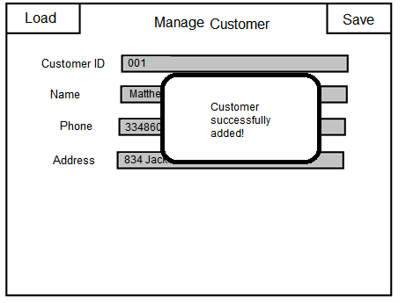

Add new purchase/update current purchase:

Default:



Clicking “Add new Purchase” and inputting info:

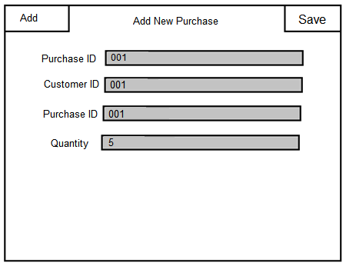

Clicking “Add”:

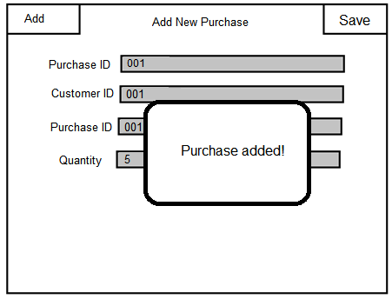

Customer UI and use case:

Making a purchase:

Default:

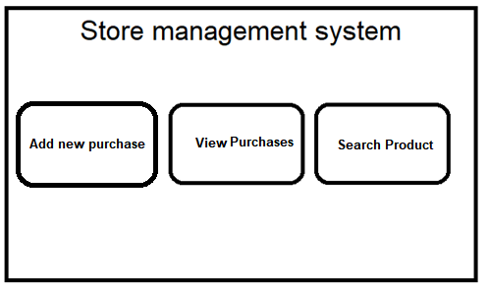

Clicking “Add new Purchase” and inputting info:



Clicking “Add”:



Viewing purchases:

Default:



Click “View purchases”:

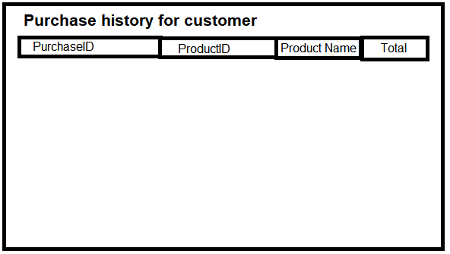

Search for product info:

Default:



After clicking “search product”:

